**EXPERIMENT 4**

**Aim :**

Write a Program for Wireless Network Simulation between 3 Nodes.

**Code :**

#Wireless Network Simulation - as the nodes come within their hearing range, the packets are exchanged

#define options

set val(chan) Channel/WirelessChannel ; #channel type

set val(prop) Propagation/TwoRayGround ; #radio propagation model

set val(netif) Phy/WirelessPhy ; #network interface type

set val(mac) Mac/802_11 ; #MAC type

set val(ifq) Queue/DropTail/PriQueue ; #interface queue type

set val(ll) LL ; #link layer type

set val(ant) Antenna/OmniAntenna ; #antenna model

set val(ifqlen) 50 ; #max packet in ifq

set val(nn) 3 ; #number of mobilenodes

set val(rp) DSDV ; #routing protocol

set val(x) 500 ; #X dimension of topography

set val(y) 400 ; #Y dimension of topography

set val(stop) 150 ; #time of simulation end

set ns [new Simulator]

set tracefd [open xwrls-simple.tr w]

set windowVsTime2 [open xwrls-simple-win.tr w]

set namtrace [open aftab7.nam w]

$ns trace-all $tracefd

$ns namtrace-all-wireless $namtrace $val(x) $val(y)

#setup topography object

set topo [new Topography]

$topo load_flatgrid $val(x) $val(y)

create-god $val(nn)

#configure the nodes

$ns node-config -adhocRouting $val(rp) \

-llType $val(ll) \

-macType $val(mac) \

-ifqType $val(ifq) \

-ifqLen $val(ifqlen) \

-antType $val(ant) \

-propType $val(prop) \

-phyType $val(netif) \

-channelType $val(chan) \

-topoInstance $topo \

-agentTrace ON \

-routerTrace ON \

-macTrace OFF \

-movementTrace ON

for {set i 0} {$i < $val(nn) } { incr i } {

set node_($i) [$ns node] }

#provide initial location of mobilenodes

$node_(0) set X_ 5.0

$node_(0) set Y_ 5.0

$node_(0) set Z_ 0.0

$node_(1) set X_ 490.0

$node_(1) set Y_ 285.0

$node_(1) set Z_ 0.0

$node_(2) set X_ 150.0

$node_(2) set Y_ 240.0

$node_(2) set Z_ 0.0

#generation of movements

$ns at 10.0 "$node_(0) setdest 250.0 250.0 3.0"

$ns at 15.0 "$node_(1) setdest 45.0 285.0 5.0"

$ns at 110.0 "$node_(0) setdest 480.0 300.0 5.0"

#setup a TCP connection between node_(0) and node_(1)

set tcp [new Agent/TCP/Newreno]

$tcp set class_ 2

set sink [new Agent/TCPSink]

$ns attach-agent $node_(0) $tcp

$ns attach-agent $node_(1) $sink

$ns connect $tcp $sink

set ftp [new Application/FTP]

$ftp attach-agent $tcp

$ns at 10.0 "$ftp start"

#printing the window size

proc plotWindow {tcpSource file} {

global ns

set time 0.01

set now [$ns now]

set cwnd [$tcpSource set cwnd_]

puts $file "$now $cwnd"

$ns at [expr $now+$time] "plotWindow $tcpSource $file" }

$ns at 10.1 "plotWindow $tcp $windowVsTime2"

#define node initial position in nam

for {set i 0} {$i < $val(nn)} { incr i } {

#30 defines the node size for nam

$ns initial_node_pos $node_($i) 30 }

#telling nodes when the simulation ends

for {set i 0} {$i < $val(nn) } { incr i } {

$ns at $val(stop) "$node_($i) reset"; }

#ending nam and the simulation

$ns at $val(stop) "$ns nam-end-wireless $val(stop)"

$ns at $val(stop) "stop"

$ns at 150.01 "puts \"end simulation\" ; $ns halt"

proc stop {} {

global ns tracefd namtrace

$ns flush-trace

close $tracefd

close $namtrace

exec nam aftab7.nam & }

puts "running nam"

$ns run

**Screen Shots :**

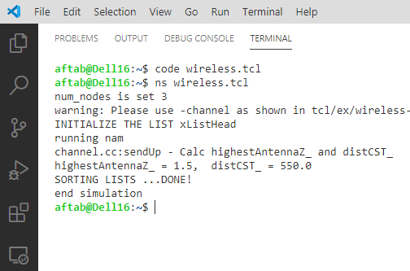

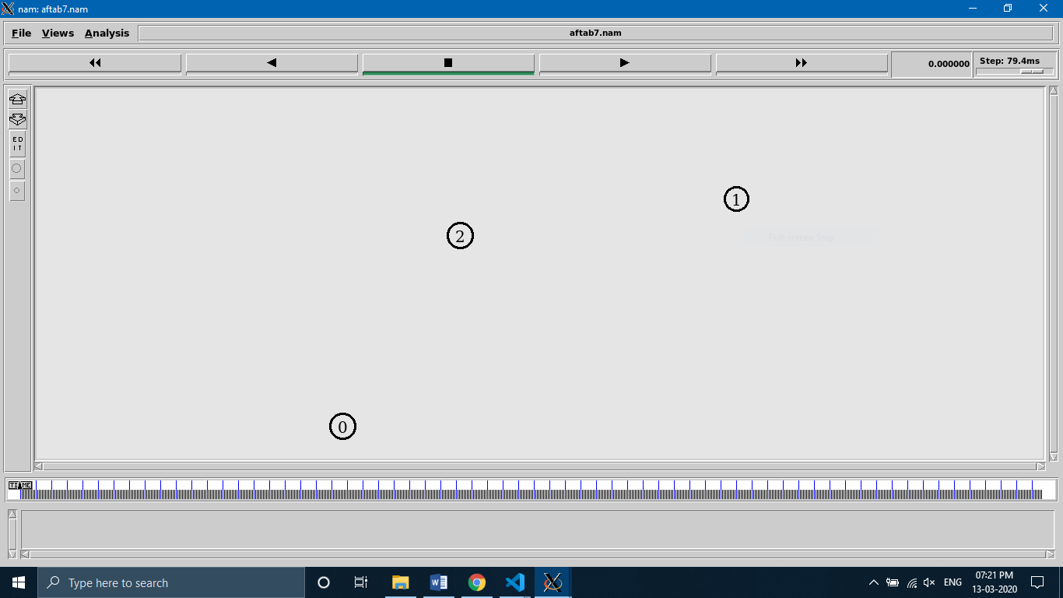

**@time = 0.00 sec**

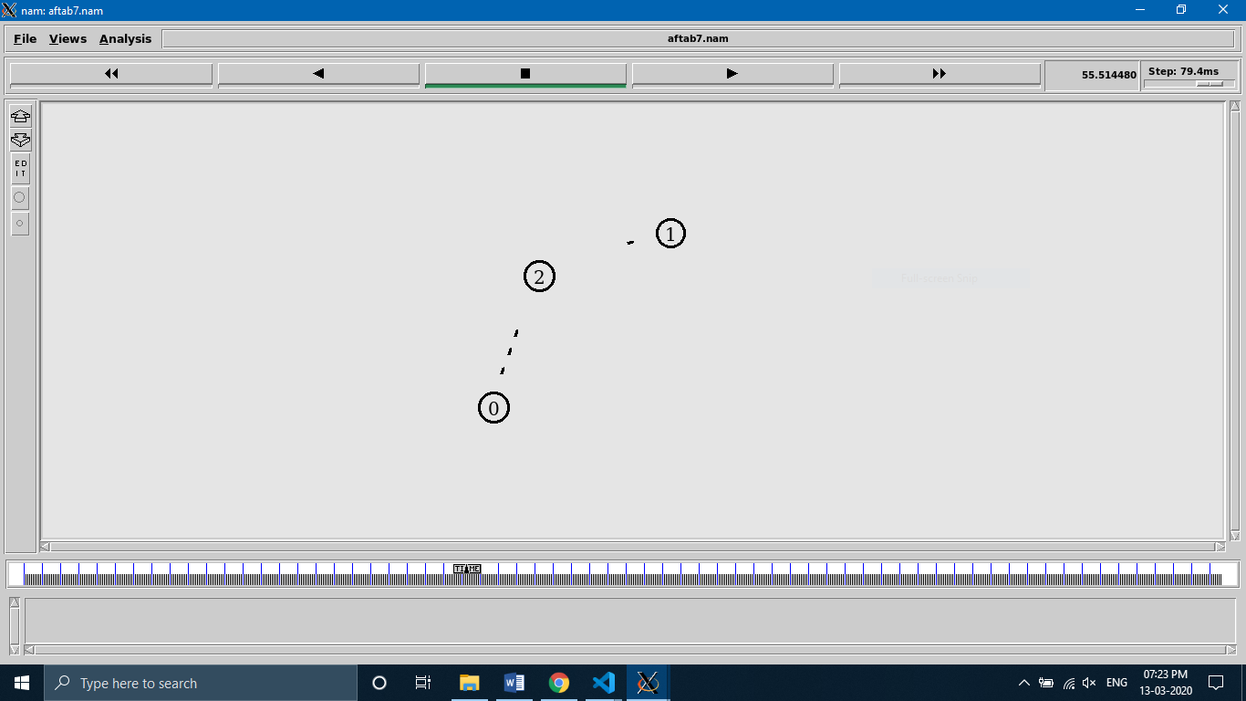

**@time = 55.51 sec**

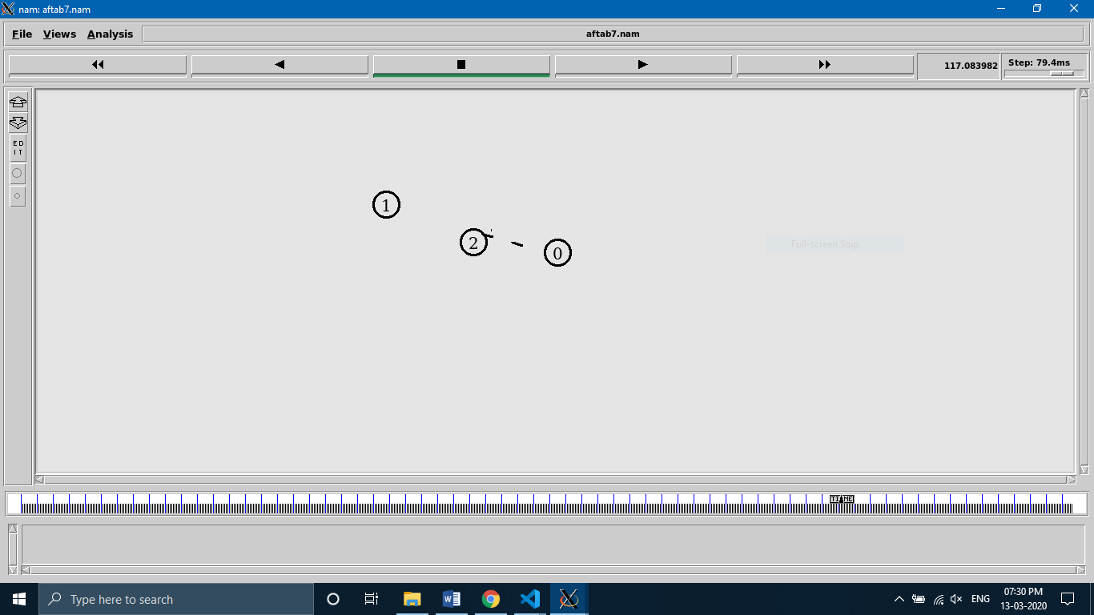

**@time = 117.08 sec**